SLOW DOWN!: On-bicycle user feedback
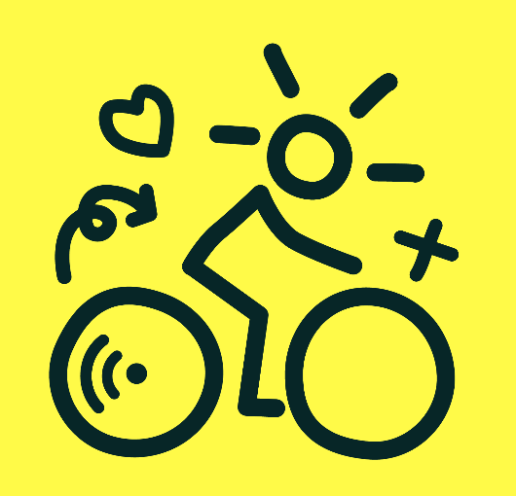
Do you want to develop technology for the next generation of bicycles? The Smart Connected Bikes project (https://www.smartconnectedbikes.nl/) aims to develop a new ecosystem of connected vehicles to make bicycle transportation more safe, reliable, and comfortable. To achieve this, high-tech communication between cyclists and their bicycle is necessary. This communication can, for example, be used to warn cyclists of dangerous situations or let them know how fast they should ride to catch the green light in time. We are currently looking for students interested in the design and technical implementation of user communication technologies on (e-)bikes.

Task Description
- Design and implement a prototype for on-bicycle communication
- The precise task can be discussed depending on your project size and personal interests, some ideas:
    - A smart helmet (LEDs, sound, …).
    - Vibrating handlebars for haptic feedback.
    - Your own idea!

Practical Information
- Student profile: Electrical Engineering, Applied Computer Science, …
- Contact person(s): Annemarie Jutte (a.m.p.jutte@saxion.nl)
- Lectoraat Ambient Intelligence: saxion.nl/ami

